Recurrent Neural Networks (RNNs)
Table of Contents
Recurrent Neural Networks (RNNs) 1
1. Introduction to RNNs 1
2. Basic Architecture of RNNs 1
3. RNN Architectures (Types of RNN Models) 2
One to One 2
One to Many 2
Many to One 2
Many to Many 2
4. Use Case: Workout Schedule Prediction 2
5. Training an RNN 2
6. Disadvantages of RNNs 2
Conclusion 3

1. Introduction to RNNs
- What is an RNN?
  - A type of neural network designed for sequential data (e.g., time series, text, speech).
  - Unlike traditional neural networks, RNNs have a memory to store past information.
  - Used for problems where previous inputs influence future outputs.
- Why Do We Need RNNs?
  - Issues with Feed-Forward Networks
    - No memory of past inputs.
    - Can only handle fixed-size inputs and outputs.
    - Cannot handle time-dependent relationships (e.g., text generation).
- How RNN Solves This?
  - Loops in the network allow information to persist.
  - Maintains knowledge of previous steps for better sequential predictions.

2. Basic Architecture of RNNs
- Key Components of RNN
  - Hidden state: Stores past information.
  - Weights and biases: Adjust network behavior.
  - Activation function (σ): Controls the output.
- Mathematical Representation

3. RNN Architectures (Types of RNN Models)
RNNs come in different architectures, depending on the input-output relationship.

One to One
- Use Case: Word prediction, stock market prediction.
- Example: Predict the next letter in a word.

One to Many
- Use Case: Auto image captioning, song generation.
- Example: Given an image, generate a sentence.

Many to One
- Use Case: Sentiment analysis.
- Example: Analyze a sentence and determine if it’s positive or negative.

Many to Many
- Use Case: Machine translation, chatbots.
- Example: Translating “casa de papel” to “paper house.”

4. Use Case: Workout Schedule Prediction
- Predicting future workouts based on past workout data.
- Today's prediction becomes tomorrow's input (time series forecasting).

5. Training an RNN
- Backpropagation Through Time (BPTT)
  - Similar to regular backpropagation but considers time dependencies.
  - Adjusts weights using gradient descent.
- Challenges in Training RNNs
  - Vanishing gradients: Makes learning long-term dependencies difficult.
  - Exploding gradients: Causes unstable training.
- Solutions
  - Use LSTM (Long Short-Term Memory) or GRU (Gated Recurrent Unit) instead of simple RNNs.

6. Disadvantages of RNNs
- Short-term memory: Struggles with long-term dependencies.
- Slow training due to sequential processing.
- Vanishing gradient problem makes learning deep dependencies hard.

Conclusion
- RNNs are powerful for sequential tasks but have limitations.
- LSTM and GRU are used to overcome these issues.
- Key Applications: Text generation, sentiment analysis, speech recognition, stock price prediction.

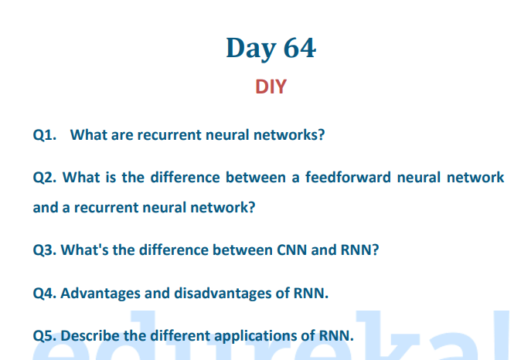

Answers to DIY Questions on RNNs

Q1. What are recurrent neural networks (RNNs)?
Answer:
Recurrent Neural Networks (RNNs) are a type of neural network designed to process sequential data. Unlike traditional feedforward networks, RNNs have loops that allow information to persist, enabling them to handle tasks where previous inputs influence future outputs. They are commonly used in speech recognition, natural language processing, and time-series forecasting.

Q2. What is the difference between a feedforward neural network and a recurrent neural network?
Answer:
Feature | Feedforward Neural Network (FNN) | Recurrent Neural Network (RNN)
Memory | No memory; each input is independent | Has memory; retains past inputs
Data Type | Works on fixed-size data | Works on sequential data
Flow of Data | Moves in one direction (input → output) | Loops allow data to persist
Example | Image classification | Text generation, speech recognition

Q3. What's the difference between CNN and RNN?
Answer:
Feature | Convolutional Neural Network (CNN) | Recurrent Neural Network (RNN)
Best for | Spatial data (images, videos) | Sequential data (text, speech, time-series)
Structure | Uses convolutional layers to extract features | Uses loops to store previous state information
Processing | Processes entire input at once | Processes input step by step over time
Use Cases | Image recognition, object detection | Language modeling, sentiment analysis

Q4. Advantages and disadvantages of RNN
Answer:
✅ Advantages of RNN:
- Remembers past inputs through hidden states.
- Good for sequential tasks like time-series forecasting.
- Can handle variable-length input sequences (e.g., different sentence lengths).
❌ Disadvantages of RNN:
- Vanishing gradient problem (loses long-term dependencies).
- Exploding gradient problem (unstable training).
- Slow training compared to CNNs.
- Difficult to parallelize due to sequential processing.
? Solution: Use LSTM (Long Short-Term Memory) or GRU (Gated Recurrent Unit) to overcome these issues.

Q5. Describe the different applications of RNN.
Answer:
? Applications of RNNs:
1️⃣ Natural Language Processing (NLP) → Text generation, machine translation, chatbot responses.
2️⃣ Speech Recognition → Transcribing speech to text.
3️⃣ Time-Series Forecasting → Predicting stock prices, weather conditions.
4️⃣ Sentiment Analysis → Analyzing customer reviews or social media sentiments.
5️⃣ Image Captioning → Generating descriptions for images.
6️⃣ Handwriting Recognition → Reading handwritten text.

